**Track Xpend**

**A PROJECT REPORT**

***Submitted by***

**Prachi Pancholi (20BCS1334)**

**Piyush Deep (20BCS3375)**

***in partial fulfillment for the award of the degree of***

**Bachelors of Engineering**

**IN**

Computer Science and Engineering



**Chandigarh University**

October, 2022



**BONAFIDE CERTIFICATE**

Certified that this project report **“Track Xpend”** is the bonafide work of “**Prachi Pancholi and Piyush Deep”** who carried out the project work under my/our supervision.

**SIGNATURE**

Sandeep Singh Kang

**HEAD OF THE DEPARTMENT**

CSE

**SIGNATURE**

Mr. Akashdeep Singh Chaudhary

(E13496)

**SUPERVISOR**

Assistant professor

CSE

Submitted for the project viva-voce examination held on

INTERNAL EXAMINER EXTERNAL EXAMINER

**TABLE OF CONTENTS**

List of Figures……………………………………………………………………4

Abstract…………………………………………………………………………..5

Graphical Abstract……………………………………………………………....6

Chapter 1………………………………………………………………………... 7

Chapter 2………………………………………………………………………..10

Chapter 3………………………………………………………………………..13

**Chapter 4. ………………………….………………………………………..….16**

**Chapter 5. …………………………………………………………………...….17**

References……………………………………………………………………….18

**User Manual …………………………………………………………………………………..19**

List of Figures

Figure1………………………………………………………………………………….. 8

**Figure 2………………………………………………………………………………….15**

**Figure 3………………………………………………………………………………….19**

**Figure 4………………………………………………………………………………….20**

**Figure 5………………………………………………………………………………….20**

**Figure 6………………………………………………………………………………….21**

**Figure 7………………………………………………………………………………….21**

**Figure 8………………………………………………………………………………….22**

**Figure 9………………………………………………………………………………….22**

**Figure 10……………………………………………………………………………..….23**

**Figure 11……………………………………………………………………………..….23**

**ABSTRACT**

Keeping on top of expenses can be a big hassle when you are just trying to get on with your work, especially if it is grown into a big pile of unprocessed paperwork!

“Expenses" are business costs that you pay for yourself, which the business may later reimburse you for. Examples would be if you used a personal credit card to buy a train ticket to go and visit your client, or if you bought a stamp at the post office and paid with your own cash. The long name for expenses is "out-of-pocket expenses".

Managing expenses are a piece of work which takes much time and also good number of efforts. Track Xpend is based on an expense tracking system. This project aims to create an easy, faster, and smooth tracking system between the expense and the income. This project also offers some opportunities that will help the user to sustain all financial activities like digital automated diary. So, for the better expense tracking system, we developed this project that will help the users a lot. Most of the people cannot track their expenses and income one way they face a money crisis, in this case daily expense tracker can help the people to track income-expense day to day and making life tension free. Money is the most valuable portion of our daily life and without money we will not last one day on the earth. So, using the daily expense tracker is important to load a happy family.

Track Xpend helps the user to avoid unexpected expenses and bad financial situations. This project will save time and provide a responsible lifestyle. This system is made and supervised by the experts and satisfying by the user. PHP, MySQL, HTML, CSS, etc. are used to develop the system. The system is tested by over 5 users, and 80% of them found the system useful. It has wide applications across the world. As statistics show that 79% of people do not track their expenses and end up messing their savings and expenditure. The overall product satisfies the need of the client and try to give the best user best experience.

**GRAPHICAL ABSTRACT**

Source [2]

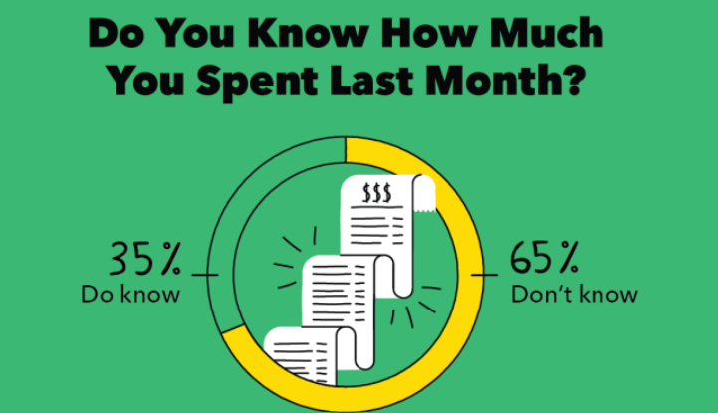

Source [2]

**CHAPTER 1**

# INTRODUCTION

## Client Identification/Need Identification/Identification of relevant Contemporary issue

Track Xpend is a daily expense tracker, one kind of digital diary that helps to keep an eye on all our money related transitions and provides all financial activities report daily, weekly, monthly and yearly. Users get notification to record expenses and incomes that are helpful to the tracking system of the application. All information is saved in offline mode so users can easily access any time and any palaces. User interface of the Track Xpend is very simple and attractive so it is easy to understand and the best way to record our financial data.

The motivation to work in this project is actually our real-life experience. As a user we face many difficulties in our daily file. In our daily life money is the most important portion and without it we cannot last one day on earth but if we keep on track all financial data then we can overcome this problem. Most of the people cannot track their expenses and income one way they face the money crisis and depression. This situation motivates us to make an android app to track all financial activities. Using the Track Xpend user can be tracking expenses day to day and making life tension free.

## Identification of Problem

# Even after such websites in existence the main issue faced by clients is to manage the expenses, they spend on each other. This led a way to this project. Clients who cannot manage their expenses and end up spending a huge amount and realize it afterwards in the end of the month.

## Identification of Tasks

## The upcoming chapter will contain the design flow, design implementation following chapters. The chapter two will be all about literature survey and background studies, a bibliometric analysis, goals, and objectives of the project. Chapter 3 will include all the aspects of the design flow and implementation of the planed methodology. The chapter 4 is about conclusion and future plans of the project, that can be implemented to improve the project scope

## Timeline

## 

## Figure 1

## Organization of the Report

**1.5.1 Chapter 1**

It consists of mainly introduction part of the website. Which includes identification of problem, possible solution, identification of task, etc.

**1.5.2 Chapter 2**

It consists of Literature review and background study about the problem. When the problem was reported, what all difficulties were faced by the clients, what is the proposed solution.

**1.5.3 Chapter 3**

Chapter 3 consists of design flow and process. It mainly focuses on Evaluation & Selection of Specifications, Design constraints, Analysis and feature finalization, Design selection, Implementation, and methodology.

**1.5.4 Chapter 4**

Chapter 4 consists of result analysis and validation . In this chapter we have written about how our project was implemented and what all features are there in the running project.

# 1.5.5 Chapter 5

# Chapter 5 consists of the conclusion of what we have made and the future aspects and working that will be added in the project for the betterment of user experience

# LITERATURE REVIEW/BACKGROUND STUDY

## Timeline of the reported problem

Expense tracking started prevailing as soon as the money concept was introduced in this world.

Everything was manually done which may have resulted into following problems:

Data is not accurate

• Reports in not up to the mark

• A single mistake in a manual calculation and cost you much

• Its time consuming boring and most of the time insufficient

• Going through all the data back then rewriting them off makes way fussier

• It can be easily stolen or loss as well your information is not safe there

Moreover, when the facility of digital payments system was deployed in the market, it was found out that people became more irresponsible about their spendings of money and hence regretted their poor money handling decisions.

Hence there was an immediate need of an advisor who could keep a track of people’s expenses and remind them to spend accordingly and efficiently.

## Proposed solutions

In the proposed system user is served with various features that will help him/her. The features are as follows:

* **Dashboard page:** The dashboard page will contain the exact numbers of today’s, yesterday’s, last week’s, last month’s, current year’s and total expenses.
* **Profile page:** This page will contain the username, email, mobile number, and registration date.
* **Xpenses page:** Xpenses here refers to expenses. In this page user gets two options i.e., Add expense and Manage expenses.
* **Xpenses report page:** Xpenses here refers to expenses. This page will get three options: Day based expense, month-based expense and yearly expense.
* **Change Password:** In this page user will get an option to change his/her passwords.
* **Logout:** In this page user will be able to change password of account.

## Bibliometric analysis

* Analysis of the key features of this project like daily expense logs.
* Analyzing every possible aspect of possible solutions and service that can be provided to the client.
* The product was found effective in a fair amount as in there were good results of expense records entered by the user.
* Product usually seemed to solve the main objective that is management of expenses.

## Review Summary

So, before this project you had to write down your expenses on a hardcopy that is a diary or a notebook. But after the successful deployment of this project your work is made much easier with the Track Xpend website.

As in recent decade the internet and browser usage has been growing exponential and almost every person uses websites for several purposes, this project will also grow at a good rate as it will surely solve various problem related to expense management. It will serve as a good companion to individuals, corporates, government, and many more possible fields of this world.

## Problem Definition

Managing expenses of individual and showing statistics such as expenses made over in a year, month, and week. Helping client to manage their expense.

## Goals/Objectives

The purpose of this tool is to:

* Keep tracking daily expenses and budgeting.
* Easy to use User Interface for clients and easy accessibility to every feature.
* Save money for necessary expenses which in return will help to plan the future investments.
* Minimum manual calculations so that less mistakes in the numbers can be produced.
* Helping the big clients like government and corporates to manage and keep a track on their daily expenditures so that the quarterly, monthly, or annual reports may not produce foul results.

# DESIGN FLOW/PROCESS

## Evaluation & Selection of Specifications/Features

**Dashboard page:** The dashboard page will contain the exact numbers of today’s, yesterday’s, last week’s, last month’s, current years and total expenses.

**Profile page:** This page will contain the username, email, mobile number, and registration date.

**Xpenses page:** Xpenses here refers to expenses. In this page user gets two options i.e., Add expense and Manage expenses.

**Xpenses report page:** Xpenses here refers to expenses. This page will get three options: Day based expense, month-based expense, and yearly expense.

**Change Password:** In this page user will get an option to change his/her passwords.

**Logout:** In this page user will be able to change password of account.

All these features are based on the need of client and specifications made by them.

## Design Constraints

The design constraint related to the project are mainly the CSS styling, and making website mobile responsive. For the index page we can use a login form.

After login, on the dashboard page will be divided into several parts containing navigation for different features like expense logs and expense reports, etc.

## Analysis and Feature finalization subject to constraints

* Theabove proposed designs and features are finalized for now and some more features are there to be added in it.
* Planning to add a chart-based data interpretation techniques in the expense reports.
* Various charts can be provided to the clients for expenses and expense reports

## Design Flow

**Design 1:**

* Home page will be utilized as login page.
* The website would have a Navbar for going from one page to another.
* Notification panel for notifying when an expense is added or deleted.
* Login and registration pages would have form features with buttons.
* Header will be same for all pages which will be used as branding of the website with its name on it.
* Dashboard page would be divided into several boxes containing info.
* Other pages would have forms for the adding of their expenses and showing the expense reports.
* Buttons would be used for submission.
* New features can be added if idea pops up.

**Design 2:**

* The website would have a side bar for going from one page to another.
* Instead of a notification panel, we can use pop ups as an alternative.
* Pop ups can be of great use as client may or may not open the notification panel but pop ups always get open whenever there is a new entry in the database.
* All the other features can be same.
* New features can be added if idea pops up.

## Design Selection

After lots of pondering and trying to implement the designs, one of the main motives of the project was found to be easy to use user interface which is most beneficial to the client.

So, **DESIGN 2** is selected as it has got some unique and important features in terms of presentation and user experience than DESIGN 1.

## Methodology

Figure 2

# RESULTS ANALYSIS AND VALIDATION

## Implementation of solution

To implement the above-mentioned specifications and fulfill the needs of client, the project development uses Agile development with testing at every phase of the project cycle. System and integration testing will be done in order to confirm the integrity, proper working of the project at the user end. HTML, JavaScript, CSS and PHP, stack are used to develop the complete project, the main reason behind choosing this tech stack is that it has wide community support, it is in demand and provides very awesome user experience. The JavaScript has the ability of making web applications that are responsive in nature. Using PHP for the database and storing user data, for better user interface, CSS is being used. The client can navigate from one page to another using the side panel. The dashboard page will contain the exact numbers of today’s, yesterday’s, last week’s, last month’s, current years and total expenses. Profile page contains the username, email, mobile number, and registration date. In this page user gets two options i.e., Add expense and Manage expenses. Xpenses here refers to expenses. Expenses report page will get three options: Day based expense, month-based expense, and yearly expense.

The project is being tested on five users and they rated it 80% based on usability and user experience.

# CONCLUSION AND FUTURE WORK

## Conclusion

The project is a full-fledged website that include backend, frontend, and database. It allows users to register and login, go on profile page to check their registered details, keep track of their expenses throughout the week, month, or even year. As the name suggests, “Track Xpend,” it enables user to “manage pays.” Expenditure should be hustle free and relaxing and this is what the website makes it possible.

The client specifications and requirements are being made complete through the

## Future work

## User support page for providing support to user, reporting bugs and any issues which they face.

## Making a small note section for client, so that they can make notes about the day expenses.

## Adding graphical data, such as pie chart, bar charts to make data visualization more appealing and make interpolation easy.

## Improving UI/UX of the complete site for better user experience.

# REFERENCES

[1] <https://www.freeagent.com/en/guides/expenses/introduction-to-expenses/>

[2] <https://mint.intuit.com/blog/budgeting/spending-knowledge-survey/>

[3]<https://www.businessinsider.in/personal-finance/61-of-u-s-adults-dont-keep-track-of-their-money/articleshow/33141118.cms>

[4] <https://www.insiderintelligence.com/topics/category/expense%20management>

[5] <https://www.investopedia.com/best-expense-tracker-apps-5114591>

4

# USER MANUAL

(Complete step by step instructions along with pictures necessary to run the project)

1. Login page, from where user can login.

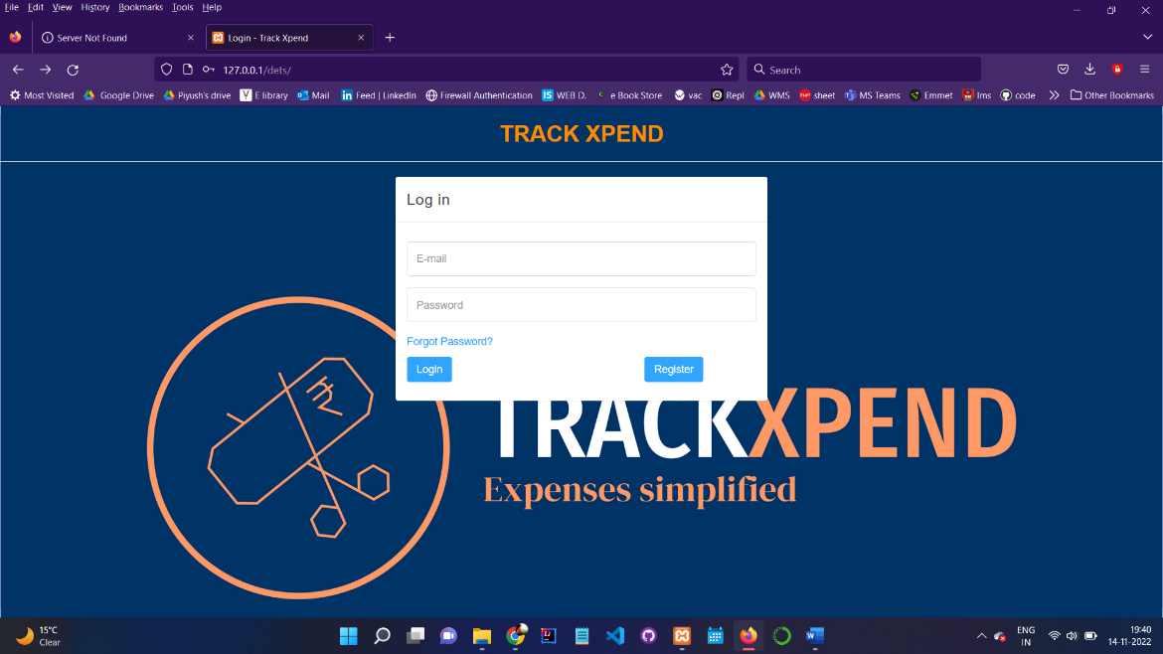

Figure 3

1. If not registered, user can register by toggling to registration form.

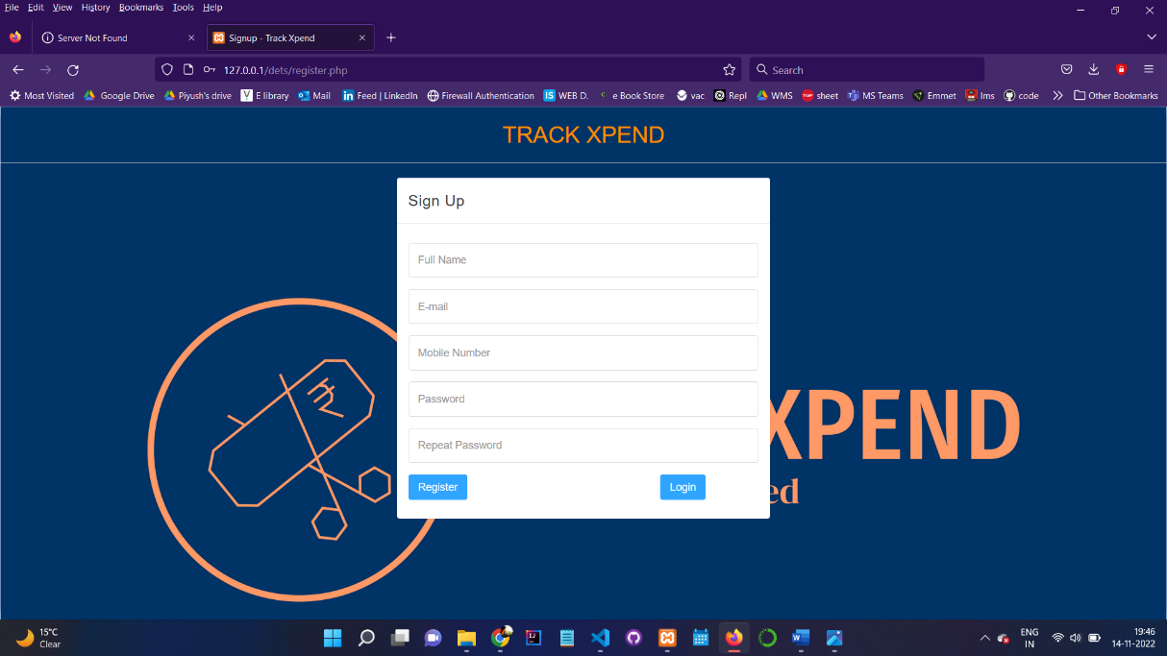

Figure 4

1. Forgot password page, once a user forget password, he/she can reset their password using email and mobile number for verification purpose.

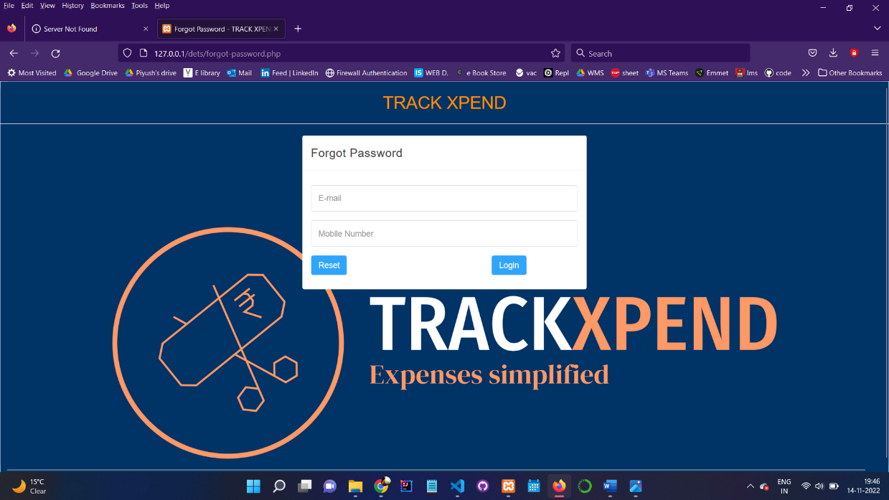

Figure 5

1. Dashboard, where user can check all the expenses, week wise, month wise and on yearly basis.

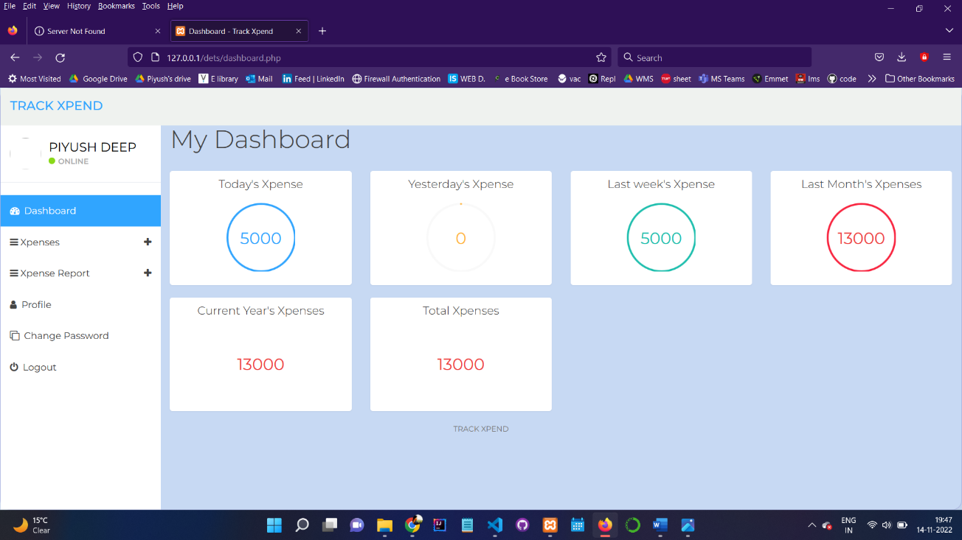

Figure 6

1. Adding new expense page, write the date, description of expense and amount.

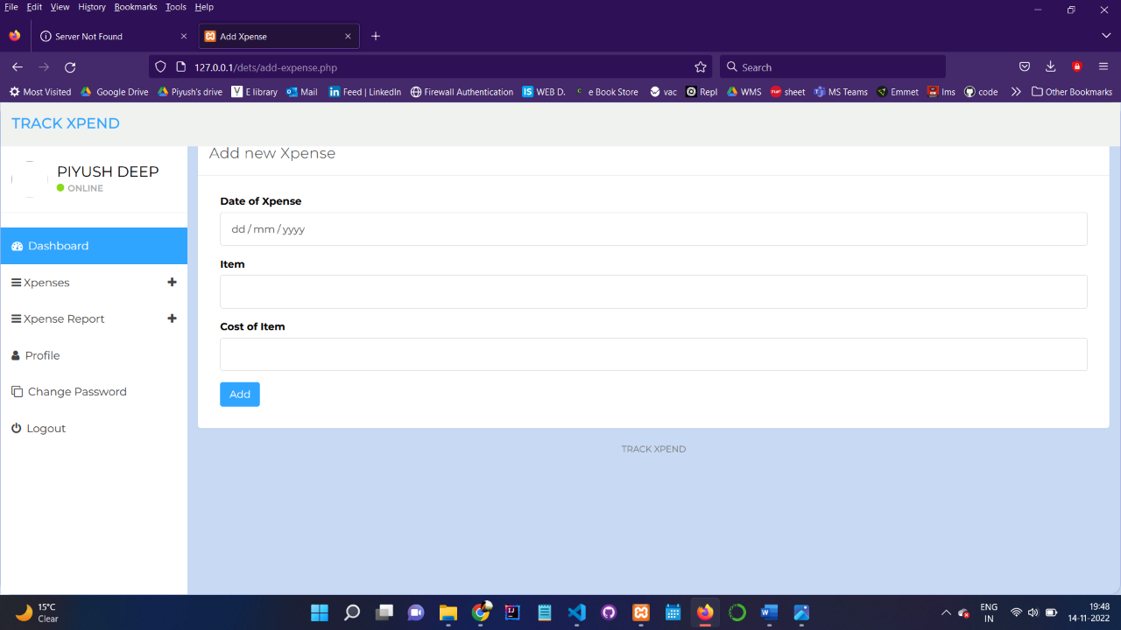

Figure 7

1. This page will show all the expenses made till date.

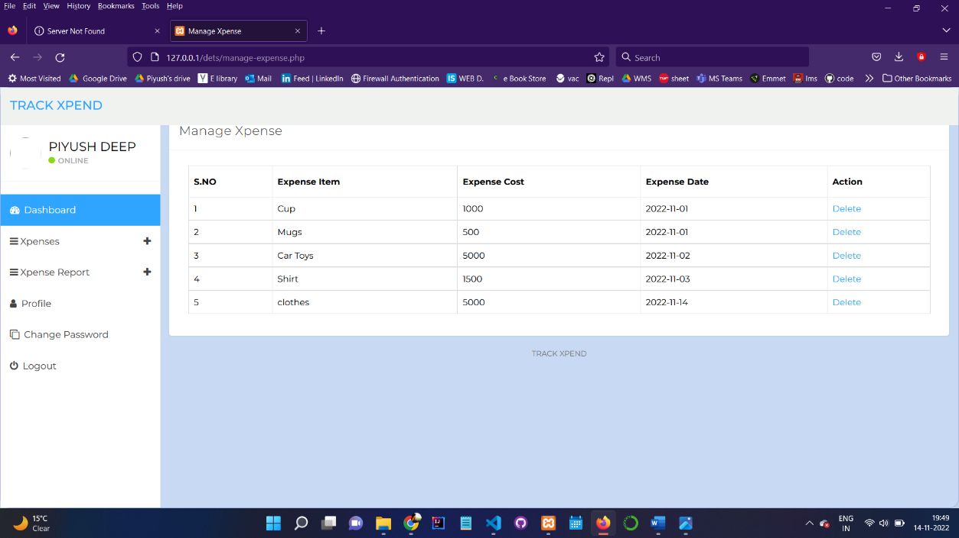

Figure 8

1. Similarly, user can enter year wise expenditure.

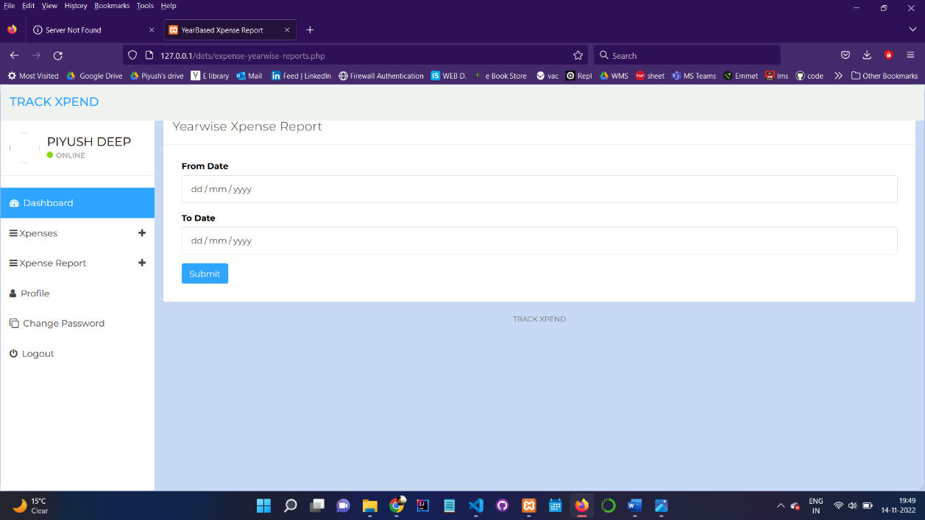

Figure 9

1. Profile section, to get to know about the registered number and email.

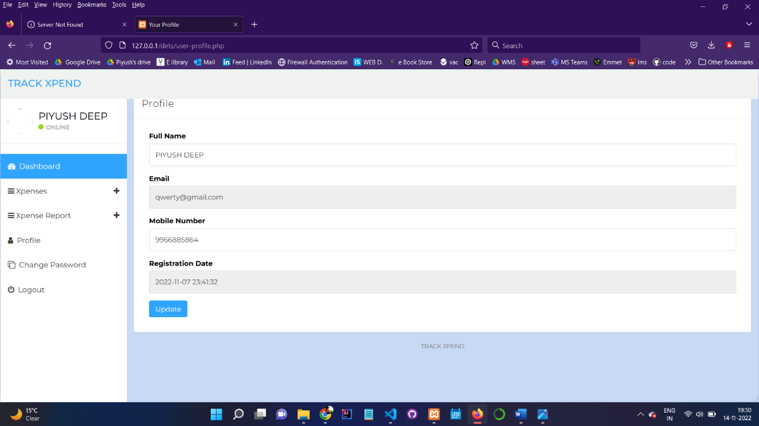

Figure 10

1. Change password section from the website.

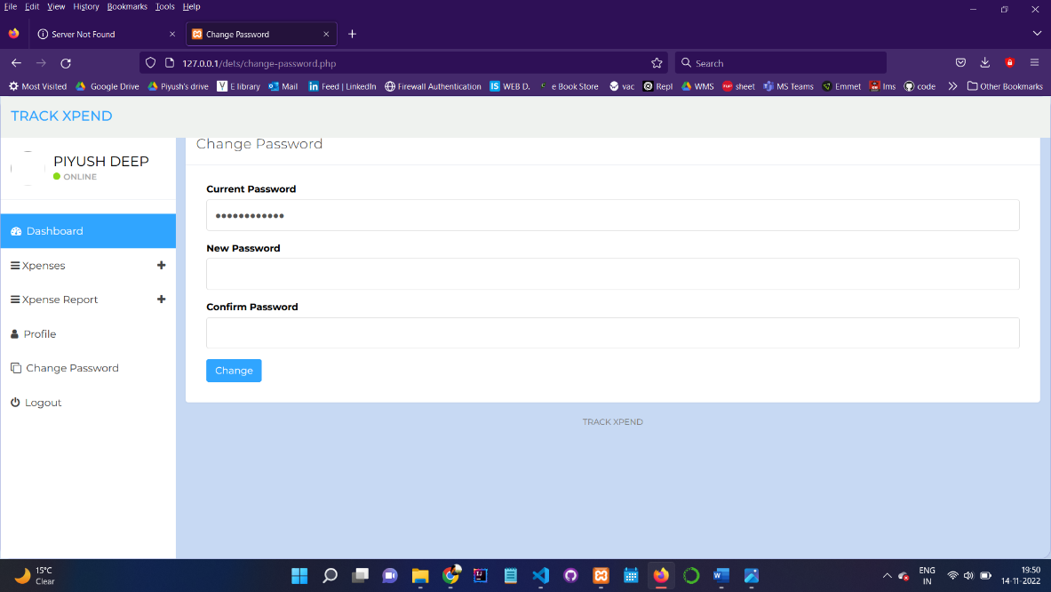

Figure 11